**SECTION A (60 Marks)**

Answer only **three** questions from this section.

1. The elements beryllium, magnesium, calcium, strontium & barium belong to group (II) of the periodic table.
2. Write the equation and state the conditions under which group (II) elements reacts with: (@04 marks)
3. Air.
4. Water.
5. Dilute sulphuric acid.
6. The atomic radii and melting points of group (II) elements in the periodic table is given below:

|  |  |  |
| --- | --- | --- |
| Elements | Atomic radius (nm) | Melting points (ᵒC) |
| Beryllium | 0.112 | 1,283 |
| Magnesium | 0.160 | 650 |
| Calcium | 0.197 | 848 |
| Strontium | 0.215 | 770 |
| Barium | 0.222 | 710 |

Explain the trend in: (@03 marks)

1. Atomic radii.
2. Melting points of group (II) elements.
3. Although beryllium is in group (II) of the periodic table, in some of its properties resemble aluminium in group (III).State the reasons why beryllium differs in some of its properties from the rest of the elements in group (II). (02 marks)
4. (a).Both phenol and ethanol contains the same functional group.
5. Name one reagent that can be used to distinguish between the two compounds. (01 mark)
6. State what would be observed if each of the compounds is treated with the reagent you have named and write equation for the reaction that occurs if any. (03 marks)
7. Describe three ways in which the chemistry of phenol is similar to that of ethanol. (03 marks)
8. Mention two uses of phenol. (02 marks)

(b).An aqueous solution of phenol turns moist blue litmus paper red whereas that of ethanol has no effect. Explain the observation. (04½ marks)

1. Write the equation and mechanism for the reaction between:
2. Phenol and 2-chlopropane in alkaline conditions. (03 marks)
3. Ethanol and methanoic acid in presence of sulphuric acid. (04½ marks)
4. (a).State Hess’s law of constant heat summation. (01 mark)

(b).Explain what is meant by each of the following terms and in each case write an equation to illustrate your answer. (@02 marks)

1. Lattice energy.
2. Hydration energy.

(c).Explain two factors that affect the value of lattice energy of a compound. (03 marks)

(d).In an experiment to determine lattice energy of anhydrous copper (II) sulphate, **4.0g** anhydrous copper (II) sulphate was added to **50g** of water and the temperature rose by **8.0ᵒC**.When **4.0g** hydrated copper (II) sulphate was added to **50g** of water dropped from **24.5ᵒC** to **23.6ᵒC**. [SHC of solution = 4.2J/g/K]

Calculate the enthalpy of solution of:

1. Anhydrous copper (II) sulphate. (03 marks)
2. Copper (II) sulphate-5-water. (03 marks)
3. State which one of the two copper (II) salts in (d) is more soluble in water and explain your answer. (03 marks)
4. Using a Born-Haber cycle determine the hydration energy of copper (II) sulphate. (03 marks)
5. (a)Describe how the molecular mass of a substance can be determined using freezing point depression method. Diagram not required) (07 marks)
6. Explain why the method you have described in a (i) is not suitable for determining the molecular mass of a polymer. (02 marks)
7. Calculate the freezing point of a solution containing 4.2g of ethane-1, 2-diol.[Molecular mass = 62 & Kf for water = 1.86ᵒC/Kg] in 30g of water. (04 marks)
8. The osmotic pressure of various concentrations of solute X in methylbenzene at 25ᵒC are given below in the table.

|  |  |  |  |  |  |  |
| --- | --- | --- | --- | --- | --- | --- |
| Concentration (g/dm3) | 1.0 | 2.0 | 3.0 | 4.0 | 5.0 | 6.0 |
| Osmotic pressure (Nm-2) | 23 | 37 | 53 | 75 | 92 | 99 |

1. Plot a graph of osmotic pressure against concentration. (03 marks)
2. Use the graph you have drawn to determine the molecular mass of X. [universal gas constant, R= 8.314KJ/mol] (04 marks)

**SECTION B (40 Marks)**

Answer only **two** questions from this section.

1. The boiling points of period 3 elements are shown in the table below.

|  |  |  |  |  |  |  |  |
| --- | --- | --- | --- | --- | --- | --- | --- |
| Formula of Chloride | NaCl | MgCl2 | AlCl3 | SiCl4 | PCl3 | S2Cl2 | Cl2 |
| Boiling point (ᵒC) | 1,465 | 1,418 | 423 | 57 | 74 | 136 | -35 |

1. Explain the trend in boiling points. (10 marks)
2. State the conditions and write the equation for the reaction between: (@02 marks)
3. AlCl3 and water.
4. Chlorine and iron.
5. MgCl2 and sulphuric acid.
6. SiCl4 and calcium hydroxide powder.
7. S2Cl2 and dilute sodium hydroxide solution.
8. Complete the following equations and write the suggested mechanism.



1. (a).The standard electrode potential for some half-cells are given below: Fe3+(aq)/Fe2+(aq) +0.76V || I2(aq)/I-(aq) +0.54V
2. What is meant by the term standard electrode potential? (01 mark)
3. Using a well labelled diagram, describe how the standard electrode potential of iron (III) sulphate can be determined. (06 marks)
4. Why is it not possible to measure the standard electrode potential of iron (III) sulphate absolutely? (02 marks)
5. Write:
6. The cell convention and equation for the overall reaction that occurs when the electrode potentials in (a) above are combined. (02½ marks)
7. Calculate the overall electrode potential for the cell. (01½ marks)
8. State whether the reaction in (b) (i) is feasible or not. Give a reason for your answer. (01 mark)
9. A current of 40.5A was passed via molten lead (II) bromide for 4 hours and bromine liberated reacted with 94.0g of hydroxylbenzene. Calculate the number of moles of: (@02 marks)
10. Bromine liberated.
11. Hydroxybenzene that reacted.
12. State what is observed and write equation for the reaction that took place between bromine and hydroxylbenzene in (c) above. (02 marks)
13. (a).Describe how aluminium can be extracted from bauxite. [Your answer should include relevant equations where necessary] (10 marks)
14. (i) Briefly describe how hydrated aluminium chloride, [AlCl3.6H2O] can be prepared from aluminium. (03 marks) (ii)State what would be observed when hydrated aluminium is strongly heated and write equation for the reaction. (02½ marks)

(iii)State what would be observed when sodium carbonate solution is added to concentrated solution of aluminium chloride. (04½ marks)

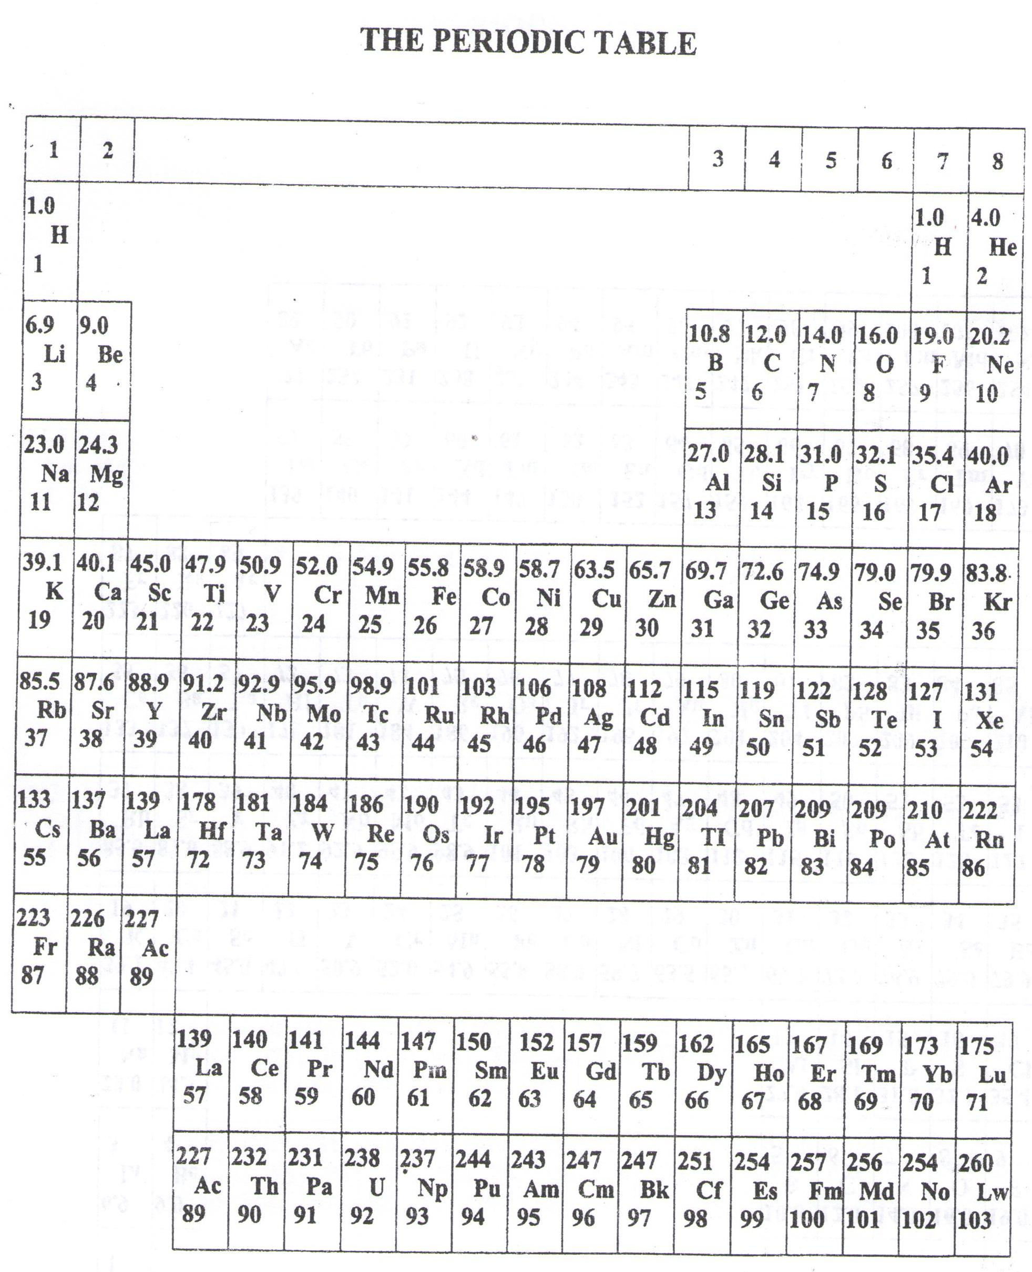

* ===END===

WELCOME TO SENIOR SIX, YEAR 2023

This is the last page of the printed paper, Page 06